QUESTIONNAIRE EXAMPLE:
Chapter 4 Findings and Analysis
4.0 Introduction

4.1 Analysis of Smartphone Addiction Level
Introduction to this section
Demographics results go here

4.1.1 Lack of Control
Smartphone addiction can be predicted by several key behaviours, none more important than lack of control. According to Smith (2016, pg.10) “this is an indication of users not being aware of their excessive use”. Interestingly, when participants where asked whether they check their smartphone before something else, the results revealed that over half of the participants (56%) agreed as shown in figure 5.1 below. In contrast, less than a quarter (23%) of the respondents disagreed with the statement. In addition, the results showed that just about an equal amount where undecided.
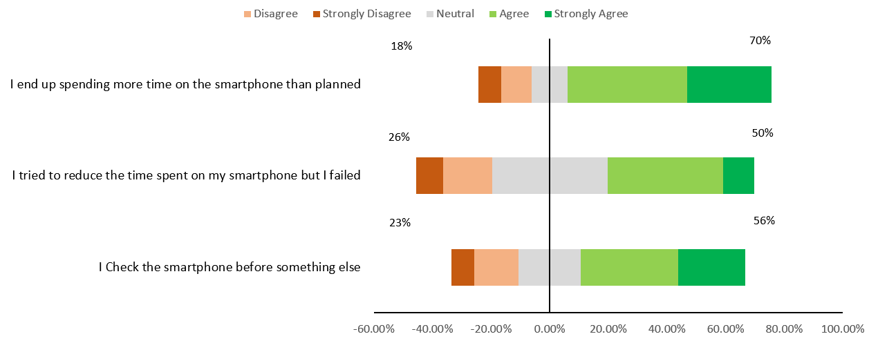
Figure 4.1 Priority Smartphone Usage

Repeat i.e. Discussion of findings for the next question/statement for this factor

Overall, in terms of lack of control the weighted mean was calculated as 3.46 (M= 3.46), this suggest that the extent to which users exhibit lack of control is moderate. Therefore, the majority of participants are aware of their excessive usage of their device since the ratio of agreement to the statement was two times that of disagreement. These findings are consistent with the views of several researchers, for instance, Park et al (2017, pg. 345) found that just over 60% of smartphone users are aware of their addiction. Furthermore, the findings are also aligned to the outcomes of a recent study completed in Europe, which postulated that “it is not uncommon for users to be aware of their excessive usage” (Guardian 2020, pg.23).

INTERVIEW EXAMPLE:

4.1.1 Lack of Control
Smartphone addiction can be predicted by several key behaviours, none more important than lack of control. According to Smith (2016, pg.10) “this is an indication of users not being aware of their excessive use”. The interview revealed two interesting themes, firstly, there was a general consensus on the priority of usage. This is evident by the responses of interviewee 1 and 2 as seen below.
Interviewee 1
“xxxxxxxxxxxxxxxxxxxxxxxxxxxxxxxxxxxxxxxxxxxxxxxxxxxxxxxx”

Interviewee 2
“yyyyyyyyyyyyyyyyyyyyyyyyyyyyyyyyyyyyyyyyyyyyyyyyyyyyy”

In addition, the interview also revealed that users may not be aware of there excessive usage, in fact interviewee 3 stated that “often time I get caught up in the moment of using my device”. These findings are similar to that of Smith (2016), who suggested that addiction is often evident by unconscious usage from time to time. Moreover, Lui et al (2019) found that smartphone users are not over alarmed by their passive usage.

